Wiley_Wordmark_white

#### Book Print Archive (BPA)

#### User Interface Specifications

***Version 7.0***

***Date: 10/30/2013***

|  |  |
| --- | --- |
|  |  |

**Document History**

|  |  |  |  |
| --- | --- | --- | --- |
| **Revision Date** | **Version Number** | **Author** | **Comments** |
| 08/27/2013 | 1.0 | Vince Mancini | Iteration #1 only – initial draft |
| 08/27/2013 | 2.0 | Sunanda Mondal | 1.Manage Company UI’s updated to include Add Location features  a) Create Company  b) Add Location  2. update User Preference feature is part of later iteration  3. Update Add to Cart feature as it is part of later iteration |
| 08/30/2013 | 3.0 | Sunanda Mondal | 1. Removed Login screen. Since it is SSO integration- no BPA login screen will be needed 2. Included Search Result page down to title record level 3. Update Advanced Search UI 4. Update manage company and contacts 5. Update “add location” with new detail and wireframe |
| 09/03/2013 | 4.0 | Shilpa Bhat  Sunanda Mondal | 1. Updated all wireframes to reflect updates 2. Update UI spec based on Debbie G’s feedback |
| 09/12/2013 | 5.0 | Sunanda Mondal | 1. Update UI spec based on Debbie G’s/ TCS feedback 2. Include “Reassign Record” feature In View WIP list 3. Update ISBN format business rules 4. Added General User views for “Contact and Company” |
| 09/26/2013 | 6.0 | Shilpa Bhat | Updated UI spec based on review comments from TCS |
| 10/30/2013 | 7.0 | Sunanda Mondal | Updated the Browse Search Result Page and removed the action button displayed for each search result |

**Table of Contents**

[Book Print Archive (BPA) 0](#_Toc367974307)

[User Interface Specifications 0](#_Toc367974308)

[Document History 1](#_Toc367974309)

[Introduction 5](#_Toc367974310)

[Conventions 5](#_Toc367974311)

[Intended Audience 5](#_Toc367974312)

[Document Structure 5](#_Toc367974313)

[Glossary 5](#_Toc367974314)

[Issues 5](#_Toc367974315)

[Structure and Navigation 6](#_Toc367974316)

[Structure 6](#_Toc367974317)

[Navigation 7](#_Toc367974318)

[User Interface Requirements 12](#_Toc367974319)

[0.0 Home Page 12](#_Toc367974320)

[Description 12](#_Toc367974321)

[Navigation 12](#_Toc367974322)

[Screen Elements 13](#_Toc367974323)

[1.0 Search Archived Titles 14](#_Toc367974324)

[Description 14](#_Toc367974325)

[Navigation 14](#_Toc367974326)

[Screen Elements 14](#_Toc367974327)

[1.1 Basic Keyword Search 14](#_Toc367974328)

[Description 14](#_Toc367974329)

[Navigation 14](#_Toc367974330)

[Screen Elements 14](#_Toc367974331)

[1.2 Advanced Search 15](#_Toc367974332)

[Navigation 15](#_Toc367974333)

[Screen Elements 17](#_Toc367974334)

[1.3 Browse Search Result 19](#_Toc367974335)

[Description 19](#_Toc367974336)

[Navigation 19](#_Toc367974337)

[Screen Elements 19](#_Toc367974338)

[Description 21](#_Toc367974339)

[Navigation 21](#_Toc367974340)

[1.3.1 View Archive Title Record Bread crumb 24](#_Toc367974341)

[Description 24](#_Toc367974342)

[Navigation 24](#_Toc367974343)

[Screen Elements 24](#_Toc367974344)

[1.4 Preferences 25](#_Toc367974345)

[Description 25](#_Toc367974346)

[Navigation 25](#_Toc367974347)

[Screen Elements 25](#_Toc367974348)

[2.0 Manage Titles 28](#_Toc367974349)

[Description 28](#_Toc367974350)

[2.1 Create New Title 28](#_Toc367974351)

[Description 28](#_Toc367974352)

[Navigation 28](#_Toc367974353)

[Screen Elements 29](#_Toc367974354)

[2.2 Create Record for New Edition 30](#_Toc367974355)

[Description 30](#_Toc367974356)

[Navigation 30](#_Toc367974357)

[Screen Elements 30](#_Toc367974358)

[Description 30](#_Toc367974359)

[Navigation 31](#_Toc367974360)

[Screen Elements 31](#_Toc367974361)

[2.3 View WIP Titles 32](#_Toc367974362)

[Description 32](#_Toc367974363)

[Navigation 32](#_Toc367974364)

[Screen Elements 32](#_Toc367974365)

[3.0 Manage Contacts and Companies 37](#_Toc367974366)

[Description 37](#_Toc367974367)

[Navigation: 37](#_Toc367974368)

[3.1 Manage Contact 37](#_Toc367974369)

[Description 37](#_Toc367974370)

[3.1.1 Create Contact 38](#_Toc367974371)

[Description 38](#_Toc367974372)

[Navigation 38](#_Toc367974373)

[Screen Elements 39](#_Toc367974374)

[3.1.2 View Contacts 42](#_Toc367974375)

[Description 42](#_Toc367974376)

[Navigation 42](#_Toc367974377)

[Screen Elements 42](#_Toc367974378)

[Screen Elements 43](#_Toc367974379)

[3.1.3 Update Contact 44](#_Toc367974380)

[Description 44](#_Toc367974381)

[Navigation 45](#_Toc367974382)

[3.1.4 Delete Contact 45](#_Toc367974383)

[Description 45](#_Toc367974384)

[Navigation 45](#_Toc367974385)

[3.2 Manage Companies 46](#_Toc367974386)

[Description 46](#_Toc367974387)

[3.2.1 Create Company 46](#_Toc367974388)

[Description 46](#_Toc367974389)

[Navigation 46](#_Toc367974390)

[Screen Elements 47](#_Toc367974391)

[3.2.1.1. Add Location 48](#_Toc367974392)

[Description 48](#_Toc367974393)

[Navigation 49](#_Toc367974394)

[Screen Elements 49](#_Toc367974395)

[3.2.2 View Company 51](#_Toc367974396)

[Description 51](#_Toc367974397)

[Navigation 51](#_Toc367974398)

[Screen Elements 52](#_Toc367974399)

[Screen Elements 53](#_Toc367974400)

[3.2.3 Update Company 54](#_Toc367974401)

[Description 54](#_Toc367974402)

[Navigation 54](#_Toc367974403)

[3.2.4 Delete Company 54](#_Toc367974404)

[Description 54](#_Toc367974405)

[Navigation 54](#_Toc367974406)

# Introduction

This document defines the user interface requirements for the Book Print Archive (BPA) Application Iteration 1 functionality. This system is designed to be a direct replacement of current DART & REDCAP with new technology resulting in an enhanced web user interface and scalable architecture.

## Conventions

* References to 'system' or 'application' in this document refer to the Book Print Archive Application unless otherwise defined.
* "TBD" indicates incomplete information necessary to complete a requirement or explanation.

## Intended Audience

* Business Stakeholders & Users
* Development
* SQA Testing.

## Document Structure

This document consists of the following sections:

* **Section 1 - Introduction**: This section describes the intent and structure of the document.
* **Section 2 - Structure and Navigation:** This section gives a broad overview of the structure of the Iteration 1.0 components. It is presented in terms of application site map.
* **Section 3 - User Interface Requirements**: This section describes the requirements for the Book Print Archive user interface component. It is based upon the information in the Functional Requirements document.

## Glossary

The following terms or acronyms will be used throughout this document:

* **Button:** A GUI feature which allows a subsequent descriptive action to take place with a single left click of the mouse on the feature. The description is always textually contained within the feature itself.
* **Screen:** The operative window.
* **Menu Bar -** An in-operative, descriptive rectangle at the located at left side or top of the screen. The main menu icons are contained within.

## Issues

* **Error Messages** for each relevant conditional event still need to be defined by Business Stakeholders.
* **View Company List** along with **Update and Delete** UI capability not available as of the date this document was published,

# Structure and Navigation

## Structure

The overall structures of the Book Print Archive Iteration 1 components are shown in the following diagram:



## Navigation

Book Print Archive can be accessed by Wiley user using portal or using BPA url.

The url will be as follows-

<http://bpa.wiley.com>

(*Note: awaiting confirmation from IT –DNS team*)

Access to BPA application from portal will be provided in Tools and Resources.



The view Item detail for BPA in Tools and Resources page will be as follows:

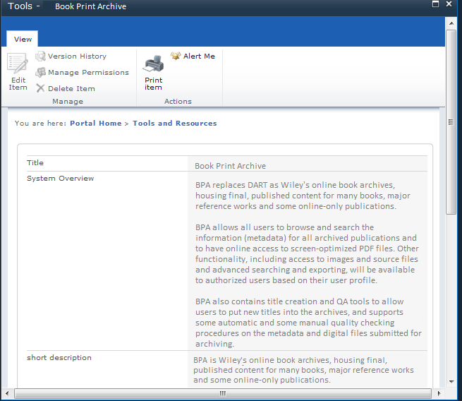

(Note: url and Wiley portal UI (above) will be ready at 3rd iteration)

Within the pages, primary navigation menu is provided on the left in a vertical list of links as well as a *'Quick Launch'* icon shown top left corner which provides the ability to quickly initiate any of the '*Create* pop-up dialog boxes without the need to view existing entries first.

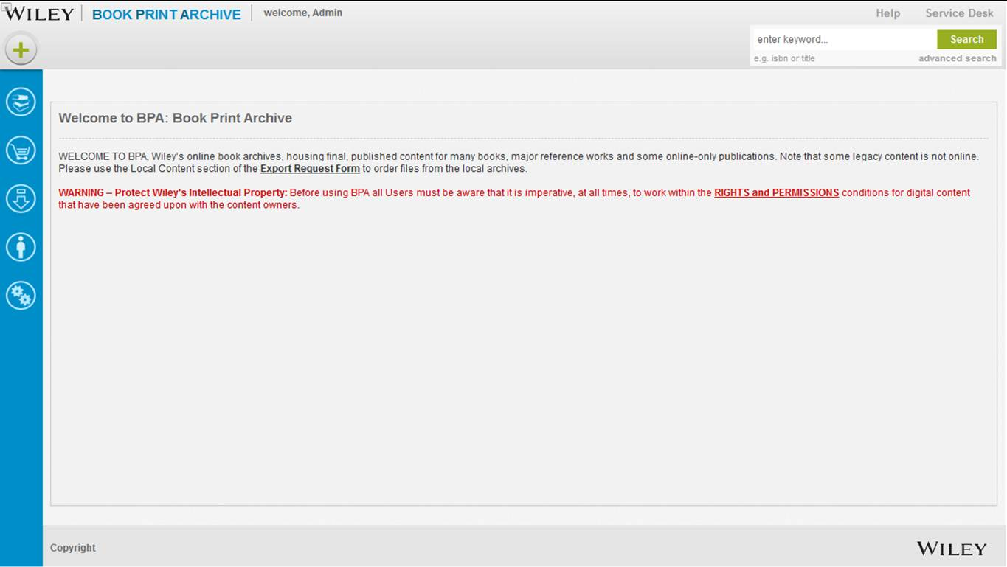

**Primary Navigation Menu – ADMIIN USER**

The Menu on the left panel available helps **Admin users** to navigate to the following features:

* WIP publication List
* Cart
* Export Request
* Contacts and Companies
* Admin Tool

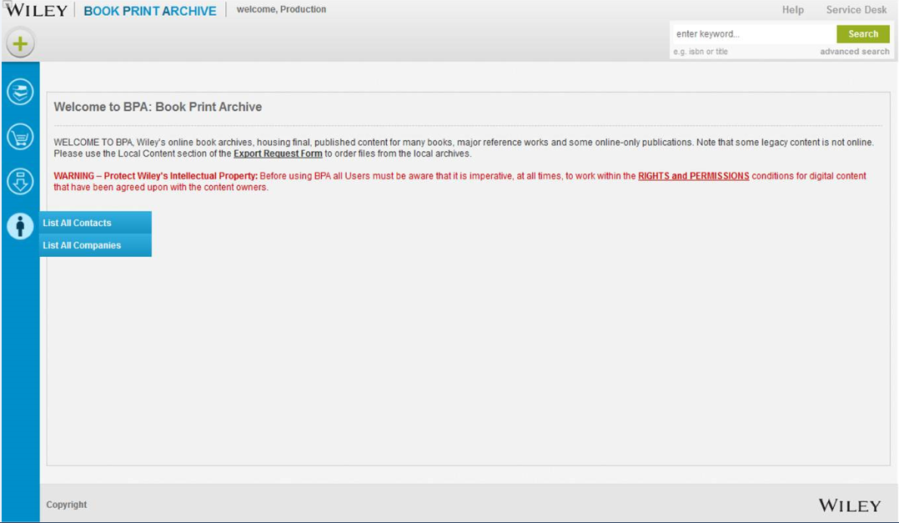

**Primary Navigation Menu – PRODUCTION USER**

The Menu on the left panel available helps **Production users** to navigate to the following features:

* WIP publication List
* Cart
* Export Request
* Contacts and Companies

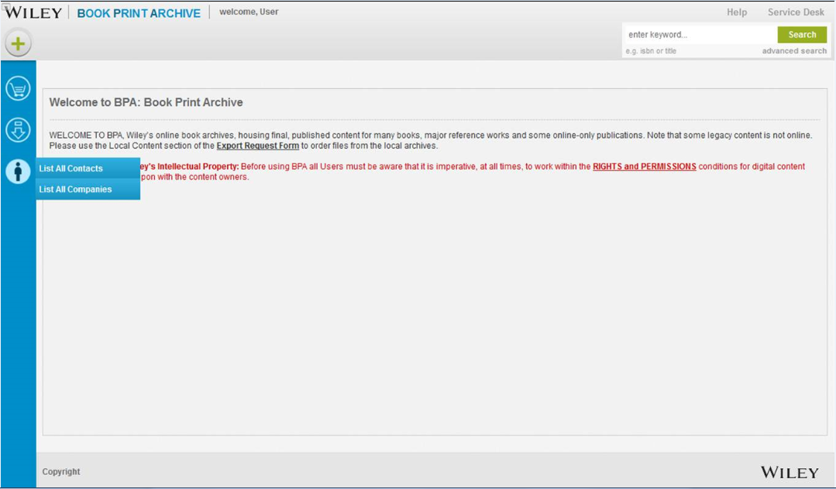

**Primary Navigation Menu – GENERAL USER**

The Menu on the left panel available helps **General users** to navigate to the following features:

* Cart
* Export Request
* Contacts and Companies

Admin User may navigate to any of the features by selecting item from menu.

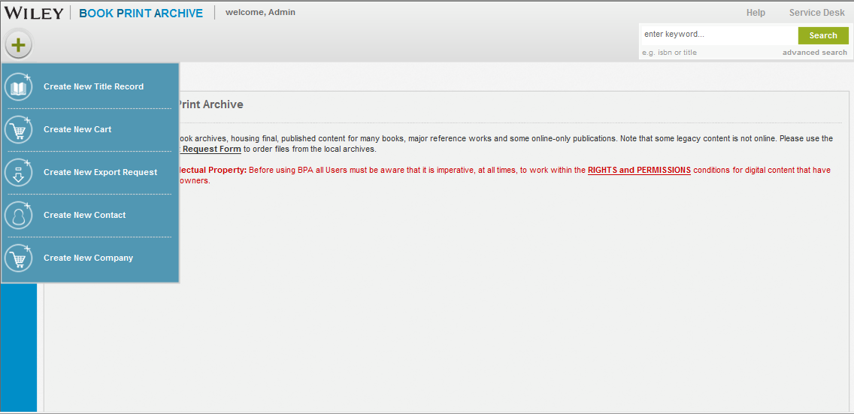

**Quick Launch drop-down Menu – ADMIN USER**

Production User may navigate to any of the features by selecting item from menu.

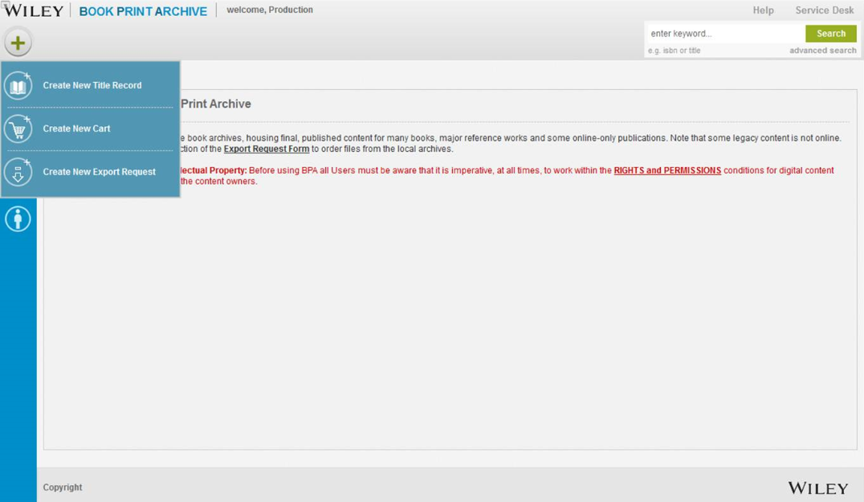

**Quick Launch drop-down Menu – production USER**

General User may navigate to any of the features by selecting item from menu.

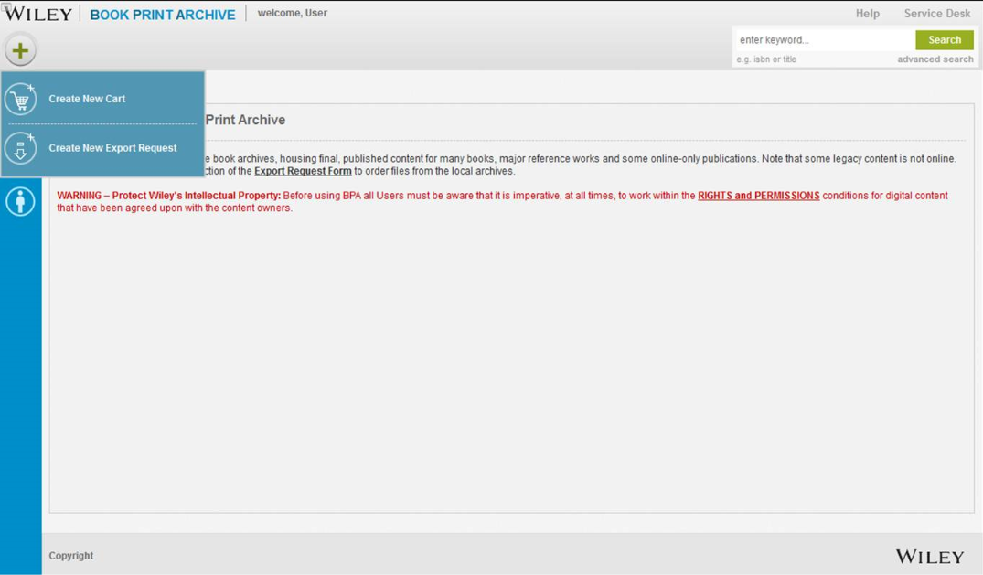

**Quick Launch drop-down Menu – GENERAL USER**

Pages are displayed in a single browser window, with the exception of ***Create*** features which are rendered in a dialog box. The dialog box contains no browser controls. Links are provided to <*Cancel>* and <*Create>* buttons:

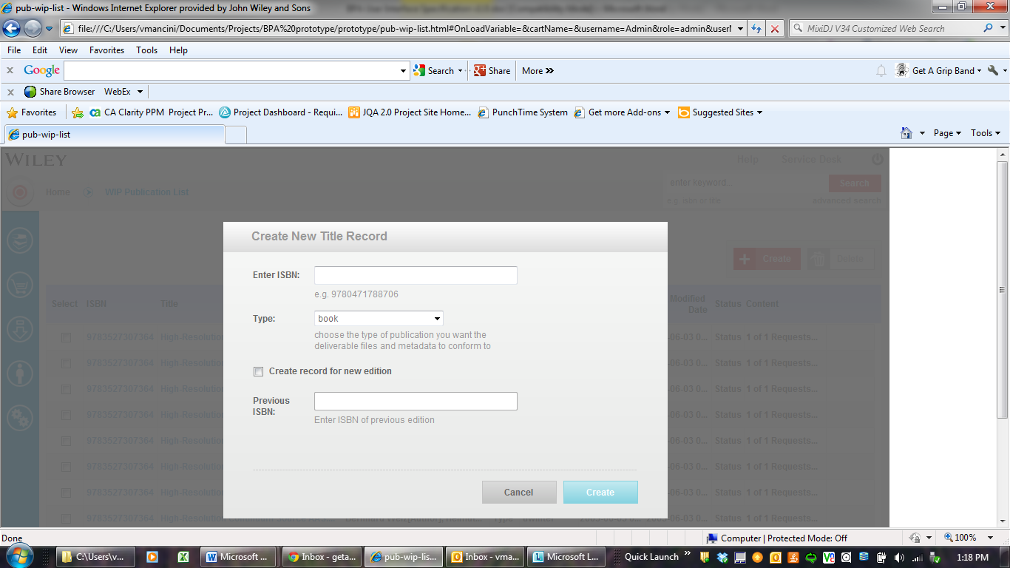

# User Interface Requirements

This major part of the document contains detailed descriptions of each page/panel in Book Print Archive Application Iteration 1.

## 0.0 Home Page



### Description

The Book Print Archive Home Page enables the user to directly access primary features that are addressed in BPA Iteration 1:

* Basic Archive & Advanced Archive Title Search
* Create New Title
* View and manage WIP Titles
* Manage Contacts & Companies

### Navigation

Navigation to the Home Page is by selecting the Book Print Archive link on the Content Technology page within the Wiley Portal. Application will also be accessible directly through its own URL - <http://bpa.wiley.com>. Using the url, user will be prompted to provide their Single Sign On credentials if user is not inside Wiley network.

The ***Quick Launch*** menu enables the user to navigate to all the ***Create*** forms directly that are available within the application:

* Create New Title
* Create New Cart *(Available in Iteration 3)*
* Create New Export Request *(Available in Iteration 3)*
* Create New Contact *(Available to Admin only)*
* Create New Company *(Available to Admin only)*

**NOTE: In new BPA system, user can revert to previous viewed by following the breadcrumbs, wherever applicable. Bread crumbs will be present on the top of the page beside the Quick Launch button.**

### Screen Elements

The following is a list of all elements of the Book Print Archive Home page:

***Help (part of iteration 3)***

|  |  |
| --- | --- |
| **Type:** | Text link |
| **Label:** | Help |
| **Behavior:** | When the link is clicked, a Help screen is launched that explains the functionality of the Book Print Archived application as well as how to navigate the site. |

***Service Desk (part of iteration 3)***

|  |  |
| --- | --- |
| **Type:** | Text link. |
| **Label:** | Service Desk |
| **Behavior:** | When the link is clicked, the servicedesk.wiley.com page is launched. Servicedesk.wiley.com will launch a custom service desk request template that is to be used to report BPA-specific service requests. |

***Basic Keyword Search***

|  |  |
| --- | --- |
| **Type:** | Text box. |
| **Label:** | Enter Keyword” |
| **Length:** | Minimum of one alpha numeric character to maximum of fifty. |
| **Default:** | n/a |
| **Validation:** | ISBN, title |
| **Behavior:** | This text box accepts the keywords which formulate the Basic Keyword Search request. User must enter a valid 10-digit ISBN (without hyphens or spaces) or a valid 13-digit ISBN (without hyphens or spaces) in order to have a successful search. |

***Search***

|  |  |
| --- | --- |
| **Type:** | Button. |
| **Label:** | Search |
| **Behavior:** | When the button is clicked, Basic Keyword Search request is submitted. If no data is contained in the Basic Keyword Search text box, the Search results list is not rendered when the Search button is clicked and a pop up message will prompt user to provide search text |

***Advanced Search***

|  |  |
| --- | --- |
| **Type:** | Text link |
| **Label:** | Advanced Search |
| **Behavior:** | When the text link is clicked, an Advanced Search screen is launched and permits search of multiple fields at the same time and use built-in operators to allow refining the search and narrow results. |

## 1.0 Search Archived Titles

### Description

Search functionality is available for users in two forms:

* Basic Keyword Search
* Advanced Search

### Navigation

Users may access both forms of Search functionality from the Home page.

### Screen Elements

Refer to the following sections

## 1.1 Basic Keyword Search



### Description

The Book Print Archive Basic Keyword Search enables the user to launch a simple query by adding basic metadata information (ISBN, title) associated with archived title records.

### Navigation

To search for records using the Basic Keyword Search:

* Enter metadata search terms (ISBN,Title) in the search text box.
* Click <***Search>***.
* System handles diacritics and wildcard entries in search criteria
* If no matching information is found, error message displayed “No Record Found”
* In no search criteria is entered into search text box, error message displayed “Please specify a search criteria”

### Screen Elements

***(Refer to Section 0.0 Home Page for description of elements***.)

Diacritics and Wildcard support information for Basic search

|  |  |  |  |
| --- | --- | --- | --- |
| **Field** | **Expected Input Format** | **Support Diacritics** | **Support Wild Card  (? And \*)** |
| ISBN | Number | No | Yes |
| Title | Text | Yes | Yes |

## 1.2 Advanced Search

**Description**

The Book Print Archive Advanced Search page enables the user to build a query step by step adding more expressions to carry out a targeted search on individual metadata information associated with archived title records.

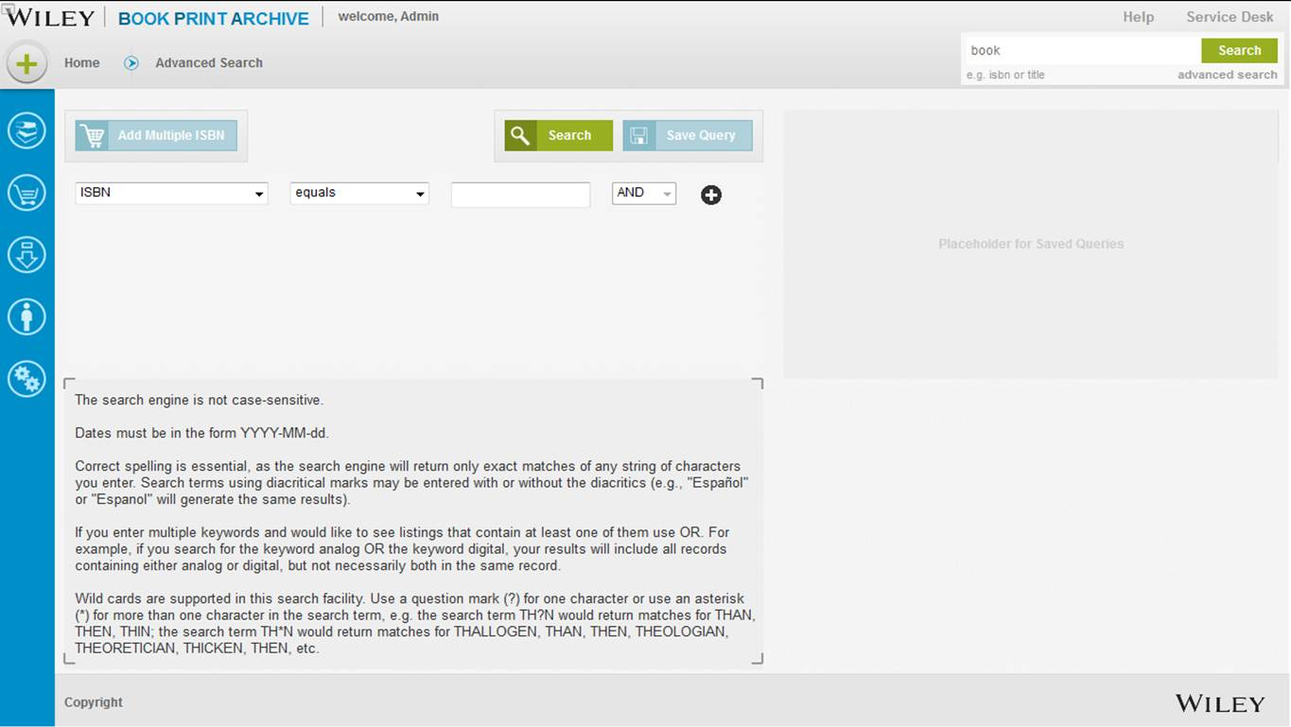

### Navigation

To search for records on the Advanced Search screen:

* Select conditional expressions to search query.
* Select metadata search terms in the corresponding field.

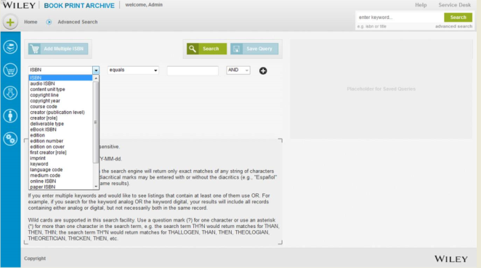

* Select the relational operators in the corresponding field

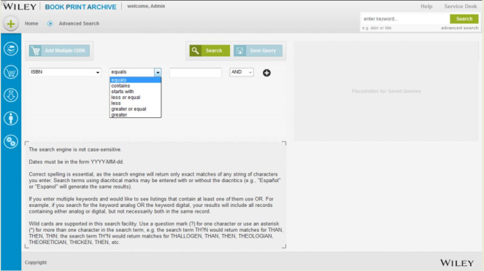

* Enter a variable based on the search terms selected.
* When the user clicks on  button a new row is added to the search query table.
* When the user clicks on the  button the row containing search query, the information is deleted.
* Click <***Search>***.
* System handles diacritics and wildcard entries in search criteria
* If no matching information is found, error message displayed “No Record Found”
* In no search criteria is entered into search text box, error message displayed “Atleast one required field is empty”

Diacritics and Wildcard Information for Advanced Search

|  |  |  |  |
| --- | --- | --- | --- |
| **Dropdown Column Name** | **Expected Input Format** | **Support Diacritics** | **Support Wild Card  (? And \*)** |
| ISBN | Number | No | Yes |
| audio ISBN | Number | No | Yes |
| content unit type | Text | No | No |
| copyright line | Text | No | No |
| copyright year | Number | No | Yes |
| course code | Text | No | No |
| creator(publication level) | Text | Yes | Yes |
| Creator [role] | Text | Yes | Yes |
| deliverable type | Text | No | No |
| eBook ISBN | Number | No | Yes |
| edition | Text | No | No |
| edition number | Number | No | No |
| edition on cover | Text | No | No |
| first creator[role] | Text | Yes | Yes |
| imprint | Text | No | No |
| keyword | Text | Yes | Yes |
| language code | Text | No | No |
| medium code | Text | No | No |
| online ISBN | Number | No | Yes |
| paper ISBN | Number | No | Yes |
| product line | Text | No | No |
| publication date | Date | No | No |
| publication status | Text | No | No |

### Screen Elements

The following is a list of all elements in the Advanced Search page:

***Metadata Search term***

|  |  |  |  |  |  |
| --- | --- | --- | --- | --- | --- |
| **Type:** | | Drop-down list | | | |
| **Label:** | | n/a | | | |
| ***Behavior:***  ***Values:*** | | When the drop-down arrow is clicked, a list of available meta-data search terms related to the archived titles.    Complete list of values below- | | | |
| *ISBN (refer detail below)* | | *Deliverable type* | | *language code* | *publisher* | *subject 2 code* | | *title label* |
| *audio ISBN* | | *eBook ISBN* | | *medium code* | *publisher division* | *subject 2 name* | | *type* |
| *Content unit type* | | *Edition* | | *online ISBN* | *publisher location publishing editor code* | *subject BISAC* | | *\** |
| *Copyright line* | | *edition number* | | *paper ISBN* | *revision* | *subject JWS* | |  |
| *Copyright year* | | *edition on Cover* | | *product line* | *series code* | *subtitle* | |  |
| *Course code* | | *first creator [role]* | | *publication date* | *series description* | *title* | |  |
| *Creator (publication level)* | | *Imprint* | | *publication notes* | *subject 1 code* | *title (publication level)* | |  |
| *Creator [role]* | | *Keyword* | | *publication status* | *subject 1 name* | *subject 2 code* | |  |

**ISBN:**

|  |  |
| --- | --- |
| **Type:** | Drop down value |
| **Label:**  **Length:** | ISBN  allow either a 13-digit numeric ISBN or a 10-digit alphanumeric |
| **Behavior:** | Displays the International Standard Book Number (ISBN) which is unique 13-digit numeric identifier. An ISBN is assigned to each edition and variation and separates its parts with either a hyphen or a space. The text box will accept the ISBN with or without hyphen or spaces. |

***Relational Operator***

|  |  |
| --- | --- |
| **Type:** | Drop-down list |
| **Label:** | n/a |
| **Behavior:**  **Values:** | When the drop-down arrow is clicked, a list of pre-determined relational operators is displayed. A single relational operator is selected to formulate each conditional expression with metadata elements to narrow search results.   |  | | --- | | Equals | | Contains | | Starts with | | Less or equal | | Less | | Greater or equal | | Greater | |

***Variable***

|  |  |
| --- | --- |
| **Type:** | Text box |
| **Label:** | n/a |
| **Behavior:**  **Values:** | When a value is entered in this text box, the conditional expression needed to find an item(s) with specified properties among a collection of archived titles is completed  The value changes within the scope of a given set metadata search terms and conditional operations.   * Dates: YYYY-MM-dd format only * Accurate spelling is required in order to return exact matches |

## 1.3 Browse Search Result

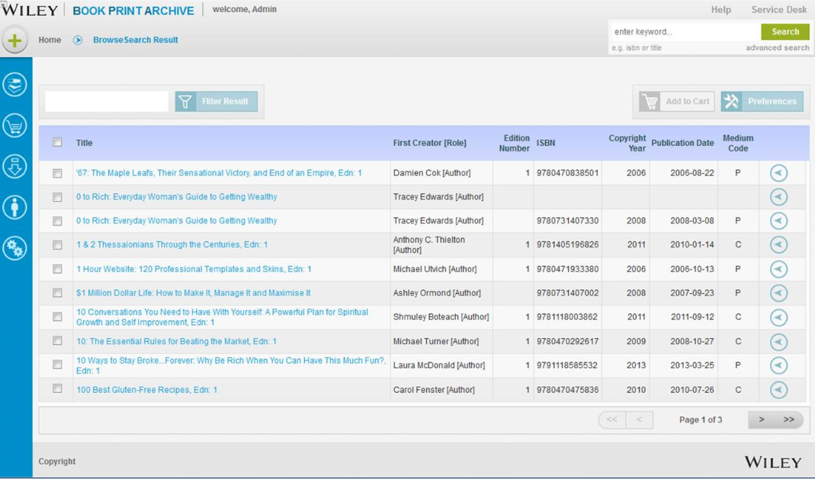

**Action Button to be removed from the browse Search result page**

### Description

The Book Print Archive Search Results page enables the user to view the records that match against all the metadata stored for archived titles. The result list represented on this screen is presented in a paginated list form. The bread crumb will show “**Browse search Result**”

### Navigation

To generate Browse Search Results screen:

* Build the query by adding as many three (3) conditional expressions to the query.
* Delete a conditional expression if needed when more than one (1) conditional expression exists.
* Click <***Search>***

### Screen Elements

The following is a list of all elements in the Browse Search Results screen:

***Select***

|  |  |
| --- | --- |
| **Type:** | checkbox |
| **Label:** | Select |
| **Behavior:**  **Default:** | When the check box is clicked, an indicator is set to include the associated record in the cart.  blank or unchecked |

***Select All***

|  |  |
| --- | --- |
| **Type:** | checkbox |
| **Label:** | None |
| **Behavior:**  **Default:** | When the check box is clicked, an indicator is set to include all associated record in the list to the cart.  blank or unchecked |

***Title***

|  |  |
| --- | --- |
| **Type:** | Column -text holder |
| **Label:**  **Behavior:** | Title  The column is sortable and clicking on the column header will sort the list in alphabetic order for that column. |
|  |  |

***First Creator [Role]***

|  |  |
| --- | --- |
| **Type:** | Column -text holder |
| **Label:** | First Creator [Role] |
| **Behavior** | Contains the full name as well as the role that applies to the name shown in parenthesis. The column is sortable and clicking on the column header will sort the list in alphabetic order for that column. |

***Edition Number***

|  |  |
| --- | --- |
| **Type:** | Column -text holder |
| **Label:** | Edition Number |
| **Behavior** | Displays number assigned to version of the content published at one time. If the author found the need to revise and update the content, a new edition number is assigned since it is different from the earlier one. The column is sortable and clicking on the column header will sort the list in alphabetic order for that column. |

***ISBN***

|  |  |
| --- | --- |
| **Type:** | Column -text holder |
| **Label:** | ISBN |
| **Behavior:** | Displays the International Standard Book Number (ISBN) which is unique 13-digit numeric identifier. An ISBN is assigned to each edition and variation and separates its parts with either a hyphen or a space. The column is sortable and clicking on the column header will sort the list in alphabetic order for that column. |

***Copyright Year***

|  |  |
| --- | --- |
| **Type:** | Column -text holder |
| **Label:**  **Length:** | Copyright Year  Date (yyyy) |
| **Behavior:** | Displays the year in which the author registered original intellectual works, both published and unpublished, with the US Copyright Office. The column is sortable and clicking on the column header will sort the list in alphabetic order for that column. |

***Publication Date***

|  |  |
| --- | --- |
| **Type:** | Column -text holder |
| **Label:** | Publication Date |
| **Length**  **Behavior:** | Date (yyyy-mm-dd)  Displays the date of distribution of copies of content to the general public for consumption with the consent of the author. The column is sortable and clicking on the column header will sort the list in alphabetic order for that column. |

***Medium Code***

|  |  |
| --- | --- |
| **Type:** | Column -text holder |
| **Label:** | Medium Code |
| **Length**  **Behavior:** | One (1) digit alpha-numeric character  Displays the type of medium used to bind a book. Most archived titles are either C or P. **C** for *cloth bound* and **P** for *paper.* The column is sortable and clicking on the column header will sort the list in alphabetic order for that column. |

***Filter Search Results***

### Description

Archived titles can be accessed via basic and advanced search options. Once search results are displayed, the results can be filtered based on Title. By entering search criteria into textbox provided, user can sort results based on the first five characters of a title.

### Navigation

To generate Browse Search Results screen:

* Enter filter criteria into textbox
* Click “Filter Result” option
* Search results are filtered based on first five characters of title entered
* Filtered results are displayed
* When filter criteria yields no results, error message prompted is “No Record Found”



***Screen Elements***

***Filter Result***

|  |  |
| --- | --- |
| **Type:** | Text box with button |
| **Label:** | Filter Result |
| **Length:** | Five characters of title |
| **Default:** | n/a |
| **Behavior:**  **Values:** | When a text is entered, the Browse Search Results list is filtered to further narrow down the group of the archived titles based on the title name. Maximum number of character system can filter by is five.  Archived titles only |

***Add to Cart. (to be addressed in Iteration 3)***

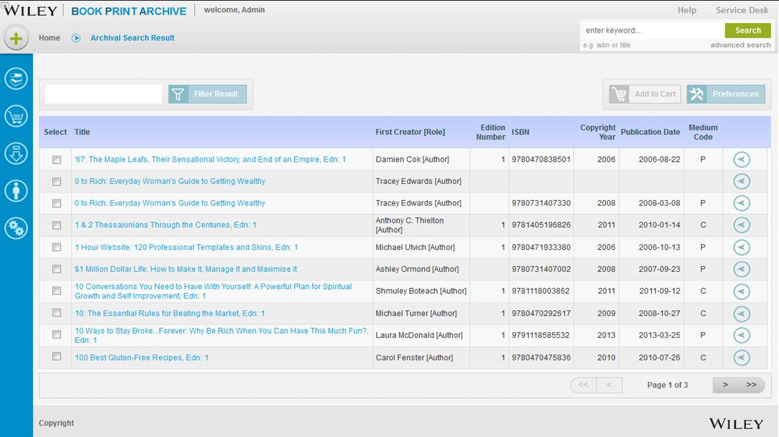

|  |  |
| --- | --- |
| **Type:** | Button |
| **Label:** | Add to Cart |
| **Behavior:** | When a particular archived title is selected from Search Result list, the user has the ability to add the title to a cart for export by clicking this button. |

***Preferences***

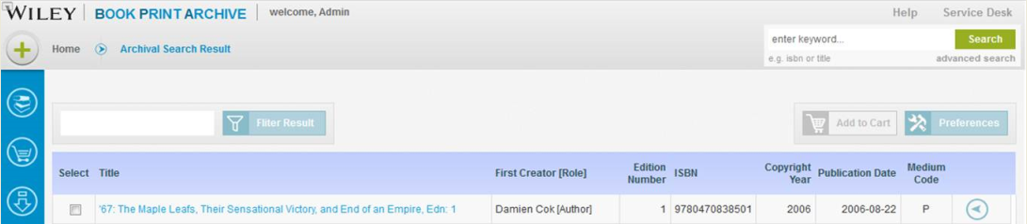

(To be addressed in Iteration 2 )

|  |  |
| --- | --- |
| **Type:** | Button |
| **Label:** | Preferences |
| **Behavior:** | When an Archived Search Result list is rendered, the user has the option to select which columns they wish to display and the number of rows per page to display. When this button is clicked, the Preferences dialog screen is rendered. |

### 1.3.1 View Archive Title Record Bread crumb

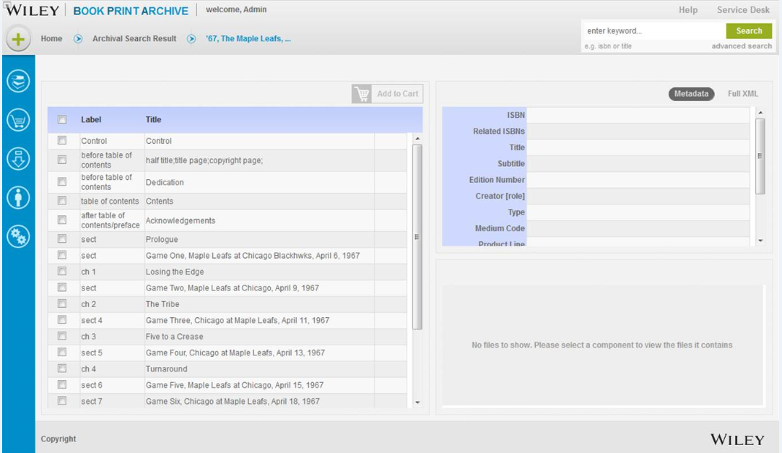

### Description

By selecting one of the title records from above shows the three panel view. The left hand panel depicts the Table of content of the record. The right hand top panel displays the metadata and the bottom right hand panel displays the resources with attachments. The default view for title record will display at metadata level. The title record is viewed in Full XML view using “full XML” button.

### Navigation

To view an archived title record screen:

* Select title from search result
* User can also select title from action item button “<” listed against each title on the right most column
* Table of content on left hand panel
* Metadata-.right hand panel- top
* Metadata- resource detail- right hand panel- button
* Full XML – click “*Full XML*” button
* **User can navigate between pages via Bread crumb**

### Screen Elements

The following is a list of all elements in the Title record screen:

***Select***

|  |  |
| --- | --- |
| **Type:** | checkbox |
| **Label:** | Select |
| **Behavior:**  **Default:** | When the check box is clicked, an indicator is set to include the associated record in the cart.  blank or unchecked |

***Select All***

|  |  |
| --- | --- |
| **Type:** | checkbox |
| **Label:** | None |
| **Behavior:**  **Default:** | When the check box is clicked, an indicator is set to include all associated record in the list to the cart.  blank or unchecked |

***Add to Cart. (to be addressed in Iteration 3)***

|  |  |
| --- | --- |
| **Type:** | Button |
| **Label:** | Add to Cart |
| **Behavior:** | When a particular archived title is selected from Search Result list, the user has the ability to add the title to a cart for export by clicking this button. |

## 1.4 Preferences

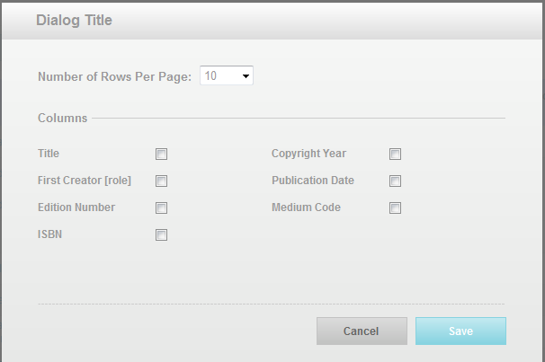

(*to be addressed in Iteration 2*)

### Description

The Preferences dialog screen enables the user to select the number of rows or records per page of archived record search results as well as the specific columns of metadata per row.

### Navigation

Preferences are displayed in a single browser window or dialog box. The dialog box contains no browser controls. Links are provided to Cancel and Save buttons.

### Screen Elements

The following is a list of all elements in the Preferences dialog box:

***Number of Rows per Page***

|  |  |
| --- | --- |
| **Type:** | Drop-down list |
| **Label:** | Number of Rows per Page |
| **Behavior:**  **Values:** | When the drop-down arrow is clicked, a list of pre-determined groups of archive title records that may be requested to be displayed.  10, 25, 50, 100 |

***Columns***

|  |  |
| --- | --- |
| **Type:** | Check box |
| **Label:** | Title, First Creator, Edition Number, ISBN, Copyright Year, Publication Date, Medium Code |
| **Behavior:**  **Default:** | When the check box is clicked, an indicator is set to include the associated column as a display preference for the Archive Search Result page.  blank or unchecked |

***Cancel/Save***

|  |  |
| --- | --- |
| **Type:** | button |
| **Label:** | Cancel, Save |
| **Behavior:** | When the *Cancel* button is clicked, the Preference dialog box is closed and focus is restored to Archive Search Results page. When the *Save* button is clicked, the Preference dialog box is closed and a message is displayed indicating that ***Preferences Successfully Saved***. |



***Title***

|  |  |
| --- | --- |
| **Type:** | checkbox |
| **Label:** | Title |
| **Behavior:**  **Default:** | When the check box is clicked, an indicator is set to include the associated column as a display preference for the Archive Search Result page.  blank or unchecked |

***First Creator***

|  |  |
| --- | --- |
| **Type:** | checkbox |
| **Label:** | First Creator |
| **Behavior:**  **Default:** | When the check box is clicked, an indicator is set to include the associated column as a display preference for the Archive Search Result page.  blank or unchecked |

***Edition Number***

|  |  |
| --- | --- |
| **Type:** | checkbox |
| **Label:** | Edition Number |
| **Behavior:**  **Default:** | When the check box is clicked, an indicator is set to include the associated column as a display preference for the Browse Search Result page.  blank or unchecked |

***ISBN***

|  |  |
| --- | --- |
| **Type:** | checkbox |
| **Label:** | ISBN |
| **Behavior:**  **Default:** | When the check box is clicked, an indicator is set to include the associated column as a display preference for the Browse Search Result page.  blank or unchecked |

***Copyright Year***

|  |  |
| --- | --- |
| **Type:** | checkbox |
| **Label:** | Copyright Year |
| **Behavior:**  **Default:** | When the check box is clicked, an indicator is set to include the associated column as a display preference for the Browse Search Result page.  blank or unchecked |

***Publication Date***

|  |  |
| --- | --- |
| **Type:** | checkbox |
| **Label:** | Publication Date |
| **Behavior:**  **Default:** | When the check box is clicked, an indicator is set to include the associated column as a display preference for the Browse Search Result page.  blank or unchecked |

***Medium Code***

|  |  |
| --- | --- |
| **Type:** | checkbox |
| **Label:** | Medium Code |
| **Behavior:**  **Default:** | When the check box is clicked, an indicator is set to include the associated column as a display preference for the Browse Search Result page.  blank or unchecked |

## 2.0 Manage Titles

### Description

For Iteration 1.0, The ***Manage Titles*** functionality is decomposed into three distinct features:

* Create New Title
* Create Record for New Edition
* View WIP Titles

## 2.1 Create New Title

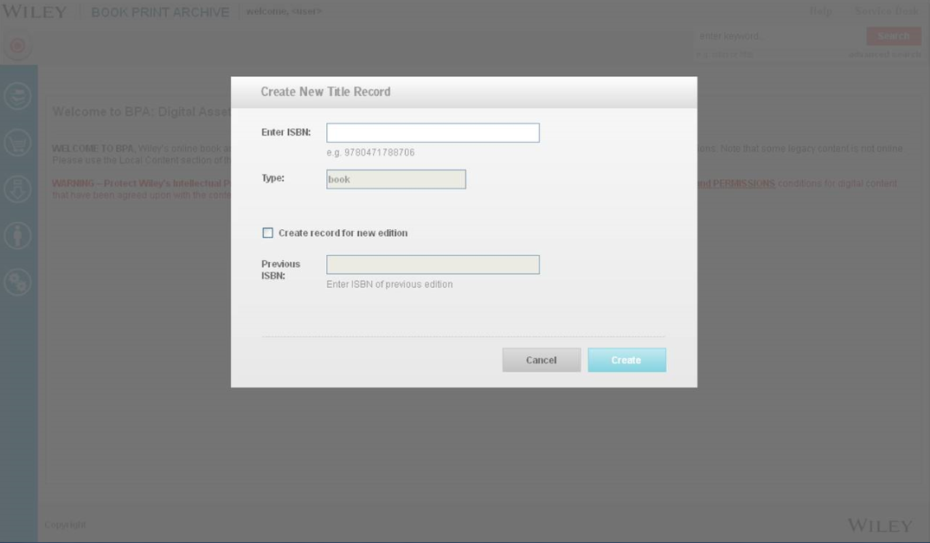

### Description

The ***Create New Title***  page allows the user to:

* Create a new title record for new content to be archived
* Create a title record for a new edition of existing archived content

### Navigation

This page is accessed through the ***Quick Launch*** drop-down menu page on the application Home page.When the ***Create New Title Record*** menu link is clicked, the ***Create New Title Record*** dialog box is rendered with no browser controls. Once the new metadata (ISBN) is entered, the <***Create>*** button is clicked and the record creation process is initiated and on success a message is displayed “Title Record successfully created”. The user has an option to exit without saving the record and corresponding information by clicking the <***Cancel>*** button. The WIP publication list displays the new title in the list. WIP list is by default sorted based on Date of Request with the newest title on top (descending order). If ***<Create>*** is performed without entering the mandatory ISBN, the following error message is displayed “The ISBN you typed in does not seem to be a valid ISBN”. If ***<Create>*** is performed on an ISBN which already has a WIP list, an error message is displayed “A record for this ISBN already exists in BPA”. If system is unable to retrieve key metadata information from Coltrane (i.e. ISBN, Title, Author Name), an error message is displayed “Metadata information is missing. Record cannot be created” **and** specifies which attribute (ISBN, Author Name and Title) is missing. Title creation does not happen.

.

### Screen Elements

The following is a list of all elements in the Preferences dialog box:

***ISBN***

|  |  |
| --- | --- |
| **Type:** | Text box |
| **Label:** | Enter ISBN |
| **Length:**  **Behavior:** | Accommodates up to a maximum of twenty-five alpha-numeric characters  Displays the International Standard Book Number (ISBN) which is unique 13-digit numeric identifier. An ISBN is assigned to each edition and variation and separates its parts with either a hyphen or a space. The text box will accept the ISBN with or without hyphen or spaces. |

***Type***

|  |  |
| --- | --- |
| **Type:** | Text box |
| **Label:** | Type |
| **Behavior:**  **Default:** | This text box is set to a default type of ***Book*** and is disabled at this time.  Book |

***Create Record for New Edition***

|  |  |
| --- | --- |
| **Type:** | Check box |
| **Label:** | Create Record for New Edition |
| **Behavior:**  **Default:** | When this box is checked, it causes the ***Previous ISBN*** text box to be enabled.  unchecked |

***Previous ISBN***

|  |  |
| --- | --- |
| **Type:** | Text box |
| **Label:** | Previous ISBN |
| **Length**  **Behavior:**  **Default:** | Accommodates up to a maximum of twenty-five alpha-numeric characters  When the ***Create Record for New Edition*** checkbox is checked, this text is then enabled and becomes a required field.  This text box defaults to **disabled**. |

## 2.2 Create Record for New Edition

### Description

The ***Create New Title*** page also is used to create a title record for a new edition of existing archived content. Since a new edition would receive a new, unique ISBN, different from the original archived content, a new title record need be created to house the updated or additional content. On successful creation, a message is displayed “Title Record successfully created” The WIP publication list displays the new title in the list. WIP list is by default sorted based on Date of Request with the newest title on top (descending order). If ***<Create>*** is performed without entering the mandatory ISBN, the following error message is displayed “The ISBN you typed in does not seem to be a valid ISBN”. If ***<Create>*** is performed on an ISBN which already has a WIP list, an error message is displayed “A record for this ISBN already exists in BPA”. If User attempts to create a new title for an ISBN with a new edition and the previous edition number entered is either missing or incorrect, the following error message is displayed “No information found for that Base ISBN”. If system is unable to retrieve key metadata information from Coltrane (i.e. ISBN, Title, Author Name), an error message is displayed “Metadata information is missing. Record cannot be created” **and** specifies which attribute (ISBN, Author Name and Title) is missing. Title creation does not happen.

### Navigation

Refer to ***Create New Title Record*** above.

.

### Screen Elements

Refer to ***Create New Title Record*** above.

**Create Record for Amended or Reprint Title**

### Description

The ***Create New Title*** page also is used to create a title record for a n amended or reprint title. Once the new metadata (ISBN) is entered, the <***Create>*** button is clicked and the record creation process is initiated, system will prompt a message to the user. On successful creation, a message is displayed “Title Record successfully created”. If ***<Create>*** is performed without entering the mandatory ISBN, the following error message is displayed “The ISBN you typed in does not seem to be a valid ISBN”. If ***<Create>*** is performed on an ISBN which already has a WIP list, an error message is displayed “A record for this ISBN already exists in BPA”. If system is unable to retrieve key metadata information from Coltrane (i.e. ISBN, Title, Author Name), an error message is displayed “Metadata information is missing. Record cannot be created” **and** specifies which attribute (ISBN, Author Name and Title) is missing. Title creation does not happen.

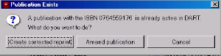

The user has an option choose to contineu creating either an Amended title, a Reprint title or to exit without creating the record by clicking the <***Cancel>*** button. The WIP publication list displays the Amended/Reprint title in the list. WIP list is by default sorted based on Date of Request with the newest title on top (descending order)

### Navigation

Refer to ***Create New Title Record*** above.

.

### Screen Elements

Refer to ***Create New Title Record*** above.

***Create Corrected Reprint***

|  |  |
| --- | --- |
| **Type:** | Button |
| **Label:** | Create Corrected Reprint |
| **Length**  **Behavior:**  **Default:** | n.a  When user selects <Create Corrected Reprint>, new title creation for Reprint record will be initiated. User can click on <Cancel> to quit task and title creation process is stopped  n.a |

***Amended Publication***

|  |  |
| --- | --- |
| **Type:** | Button |
| **Label:** | Amended Publication |
| **Length**  **Behavior:**  **Default:** | n.a  When user selects <Amended Publication>, new title creation for Amended record will be initiated. User can click on <Cancel> to quit task and title creation process is stopped  n.a |

***Cancel/Save***

|  |  |
| --- | --- |
| **Type:** | button |
| **Label:** | Cancel |
| **Behavior:** | When the *Cancel* button is clicked, the dialog box is closed and focus is restored to WIP Title list. |

## 2.3 View WIP Titles

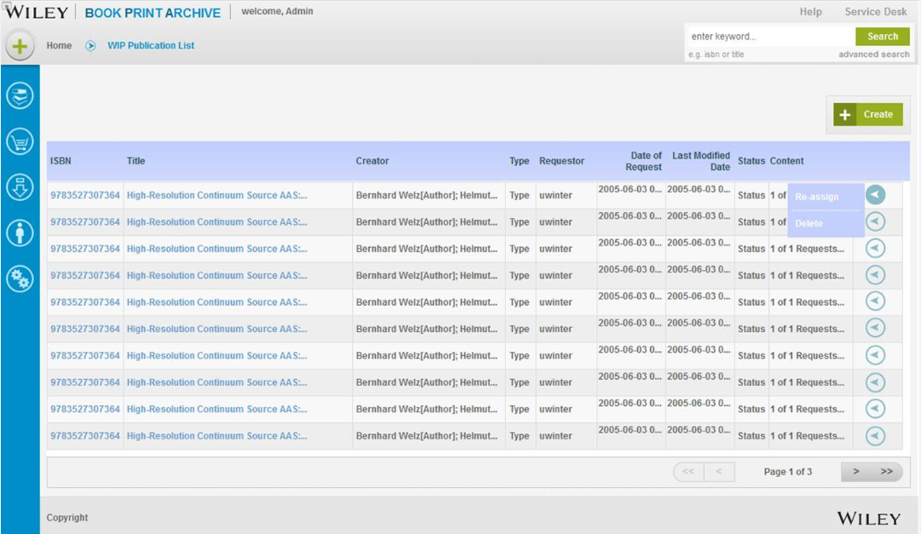

WIP Publication List icon

### Description

The ***WIP Publication List*** page allows the user to:

* View all WIP titles relevant to ID. WIP list is by default sorted based on Date of Request with the newest title on top
* Create a WIP Title record **here** rather than from ***Quick Launch*** menu
* Choose to view particular WIP title record details by selecting ***ISBN*** or ***Title*** hyper-link. ***(to be addressed in Iteration 2 )***
* Select a WIP title record or group of title records to <delete>
* Reassign WIP records to different user

### Navigation

This page is accessed through the ***Primary Navigation Menu***  on the application Home page.When the ***WIP Publication List***  icon is clicked, the ***WIP Publication List*** screen is rendered with browser controls enabled.

***Included in later iteration*** : Each WIP title record contains hyperlinks in both the ISBN and Title fields that when clicked render the ***WIP Title Record details*** dialog box. This dialog box displays the record details and allows for updating of the WIP Title Record and save the updates once edits are completed and ***<Save>*** button is clicked. The user has an option to exit without saving the edits to the record by clicking the <***Cancel>*** button.

.

### Screen Elements

The following is a list of all elements contained on the WIP Publication List screen:

***Create***

|  |  |
| --- | --- |
| **Type:** | button |
| **Label:** | Create |
| **Behavior:** | When the **<*Create>*** *button* is clicked, the Create New Title Record dialog box is rendered and focus moves away from the WIP Publications List screen. . |

***Delete***

|  |  |
| --- | --- |
| **Type:** | button |
| **Label:** | Delete |
| **Behavior:**  **Default:** | When the user selects WIP Title Record displayed in the WIP Publication List, then **<*Delete>***button is enabled. When ***<Delete>*** button is clicked, dialog box will prompt user to confirm with the message “You are about to delete item(s). This action cannot be undone in the future. Do you wish to continue?”  Once confirmed, the WIP Title Record is removed from the WIP Publications List.  disabled |

***Reassign Record***

|  |  |
| --- | --- |
| **Type:** | button |
| **Label:** | Re-assign |
| **Behavior:** | When the user select *<****Re-assign >*** button without selecting a record first – dialog box will be displayed to **< No Request selected. Please select a request from the List >.** Once user selects a record and chooses ***<Re-assign >***button, a dialog box opens requesting the user to assign the WIP request to another user. The assigned user information can be provided by giving the user’s Single Sign on username or giving user’s (first name, last name) information which is received from LDAP.(LDAP feature will be part of iteration 3)Upon assigning the request to another user, a dialog box will display **< The request might not be visible to you after you have assigned it to <<username>>. Are you sure? >** . User can select to accept, decline or cancel the request. Once title has been successfully reassigned, a message is displayed “Request has been successfully re-assigned”  In exception case, when the assigned user information is not present in LDAP, the following message will be provided **<The user <<username>> could not be found in LDAP. Request cannot be assigned to <<username>> >.** |
| **Default** | Disable |

***ISBN***

|  |  |
| --- | --- |
| **Type:** | Column : Text holder with hyper-link |
| **Label:** | ISBN |
| **Behavior:** | Displays the ***ISBN*** with hyperlink that points to the WIP Title record details and would display the detail dialog screen when the hyper-link is clicked. ***(to be addressed in Iteration 2).*** The column is sortable and clicking on the column header will sort the list in alphabetic order for that column. |

***Title***

|  |  |
| --- | --- |
| **Type:** | Column : Text holder with hyper-link |
| **Label:**  **Behavior:** | Title  Displays the ***Title*** with hyperlink that points to the WIP Title record details and would display the detail dialog screen when the hyper-link is clicked. ***(to be addressed in Iteration 2).*** The column is sortable and clicking on the column header will sort the list in alphabetic order for that column. |

***Creator***

|  |  |
| --- | --- |
| **Type:** | Column : Text holder |
| **Label:** | Creator |
| **Behavior** | Contains the full name as well as the role that applies to the name shown in parenthesis (example John H Smith [editor], Jane Doe [author]) The column is sortable and clicking on the column header will sort the list in alphabetic order for that column. |

***Type***

|  |  |
| --- | --- |
| **Type:** | Column : Text holder, display icons |
| **Label:** | Type |
| **Behavior:** |  |

***Requestor***

|  |  |
| --- | --- |
| **Type:** | Column : Text holder |
| **Label:** | Requester |
| **Behavior:** | This text box contains the Wiley SSO ID of the individual that initiated the request. The column is sortable and clicking on the column header will sort the list in alphabetic order for that column. |

***Date of Request***

|  |  |
| --- | --- |
| **Type:** | Column : Text holder |
| **Label:** | Date of Request |
| **Length:**  **Behavior:** | Date (yyyy-mm-dd)  Displays the date of request was submitted. The column is sortable and clicking on the column header will sort the list in alphabetic order for that column. |

***Last Modified Date***

|  |  |
| --- | --- |
| **Type:** | Column : Text holder |
| **Label:** | Last Modified Date |
| **Length**  **Behavior:** | Date (yyyy-mm-dd)  Displays the date the request was last modified. The column is sortable and clicking on the column header will sort the list in alphabetic order for that column. |

***Status***

|  |  |
| --- | --- |
| **Type:** | Column : Text holder, displays icons |
| **Label:** | Status |
| **Length**  **Behavior:** | Accommodates up to a maximum of twenty-five alpha-numeric characters  This text box contains the most current status of the request. The column is sortable and clicking on the column header will sort the list in alphabetic order for that column. Values listed below: |

***Content***

|  |  |
| --- | --- |
| **Type:** | Column : Text holder |
| **Label:** | Content |
| **Behavior:** | This text box contains the number of content requests for that title. The column is sortable and clicking on the column header will sort the list in alphabetic order for that column. |

# 3.0 Manage Contacts and Companies

### Description

All users are able view all listed contacts and companies irrespective of their user roles. In addition to viewing contact/company list, the Administrator role is able to create, update, view or delete contacts/companies when needed.

### Navigation:

This Contacts and Companies List page is accessed through the ***Primary Navigation Menu*** located on the left hand side of the application Homepage.

**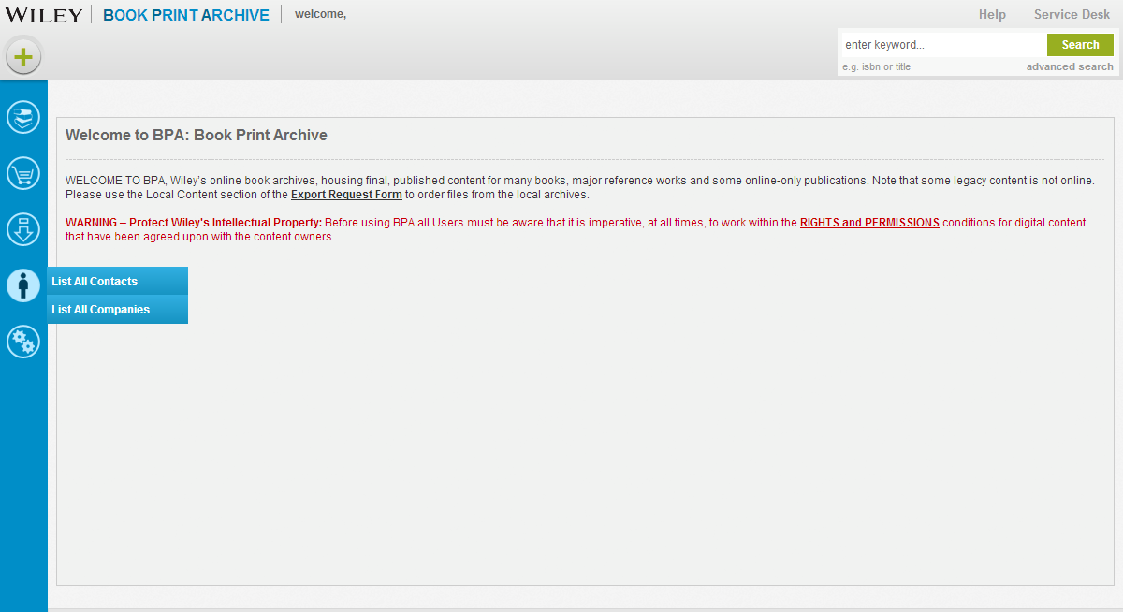**

User may navigate to the Contacts List by selecting the menu icon ***List All Contacts*** or ***List All Companies***. When clicking the menu selection, the Contacts List/ Company List is rendered in a new window with browser controls

User may navigate through ***Contacts list*** or ***Companies List*** by means of the buttons provided at the bottom of the list.

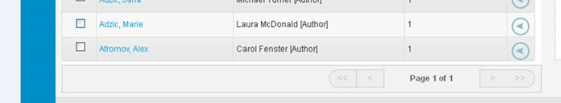

## Manage Contact

### Description

All users are able view all listed contacts irrespective of their user roles. Managing Contact list consist of creating new contact, viewing the complete list of existing contacts, updating contact information and deleting contact list. Administrator role is able to create, update, view or delete contacts when needed.

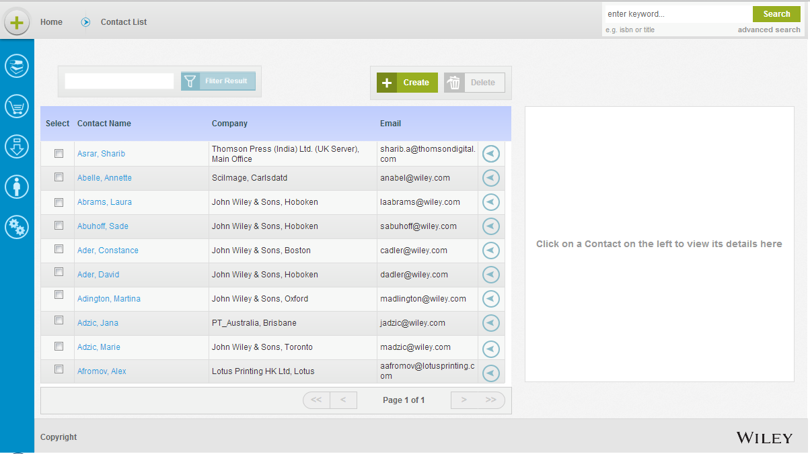

### 3.1.1 Create Contact

### Description

Administrative users are able to create a new contact by selecting ***Create New Contact*** menu option from ***Quick Launch*** menu.

### Navigation

When the user clicks on the ***Create New Contact*** option on the menu, the ***Create New Contact*** dialog box is rendered. After the user enters all the required contact information, the admin user then clicks the ***<Create>*** button. A check is put in place to verify that a contact does not already exist by the same first name and last name combination. If the contact already exists, an error message is displayed “Contact already exists”. If the contact is successfully created, a message is displayed “Contact successfully created” and the new Contact is saved and now updated in the Contacts List alphabetically based on last name in a paginated format. However, System displays the contact list with most recent page, filter and sort settings. If user does not enter all mandatory fields during creation, an error message is displayed highlighting the missing fields. Sample error message-

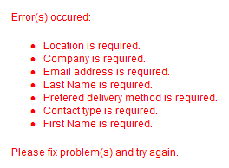

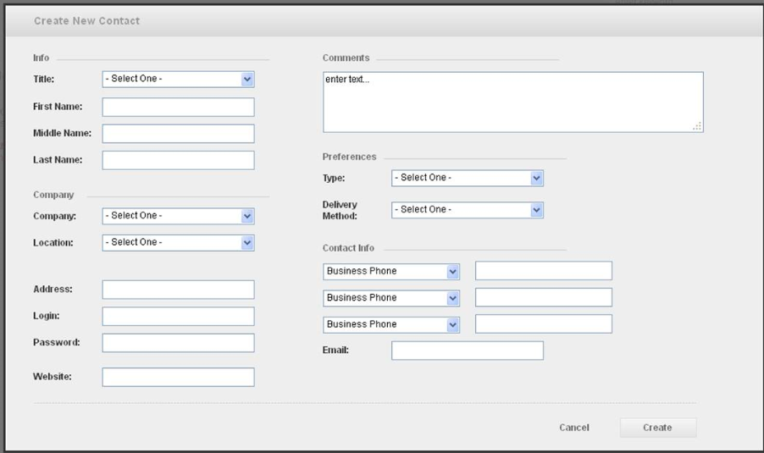

If the admin user clicks the ***<Cancel>*** button, information is not saved and the ***Create New Contact*** dialog box is closed, returning the focus to the application Home page.

### Screen Elements

The following is a list of all elements contained on the ***Contacts List:***

***Title***

|  |  |
| --- | --- |
| **Type:** | Drop down selection box |
| **Label:** | Title |
| **Values:**  **Behavior** | Mr., Mrs., Ms,. Dr (no default setting)  **Optional** - Contains the ***title*** that applies to the Contact |

***Last Name***

|  |  |
| --- | --- |
| **Type:** | text box |
| **Label:** | Last Name |
| **Length:**  **Behavior** | Accommodates up to a maximum of fifty alpha-numeric characters  **Mandatory** - Contains the ***last\_name***that applies to the Contact. Validation – alpha characters and uniqueness of Last Name/First Name combination |

***Middle Name***

|  |  |
| --- | --- |
| **Type:** | text box |
| **Label:** | Middle Name |
| **Length:**  **Behavior** | Accommodates up to a maximum of fifty alpha-numeric characters  **Optional** - Contains the ***middle\_name*** that applies to Contact. Validation – alpha characters |

***First Name***

|  |  |
| --- | --- |
| **Type:** | text box |
| **Label:** | First Name |
| **Length:**  **Behavior** | Accommodates up to a maximum of fifty alpha-numeric characters  **Mandatory** - Contains the ***first\_name***that applies to Contact Validation – alpha characters and uniqueness of Last Name/First Name combination |

***Company***

|  |  |
| --- | --- |
| **Type:** | drop-down selection box |
| **Label:** | Company |
| **Values:**  **Behavior** | ***(Refer to Company List)***  **Mandatory** – Contact must be associated with a Company that resides in **Company List** |

***Location***

|  |  |
| --- | --- |
| **Type:** | drop-down selection box |
| **Label:** | Location |
| **Values:**  **Behavior** | ***(Refer to Locations List)***  **Mandatory** – Contact must be associated with Location that resides in the **Locations List**. |

***FTP Address***

|  |  |
| --- | --- |
| **Type:** | text box |
| **Label:** | FTP Address |
| **Length:**  **Behavior** | ***(Refer to Company List)***  When user selects a Company that is associated with the Contact, the Address field on the Contact form will automatically capture FTP address associated with that Company. FTP information is editable and user can update or add the record which can differ from the company FTP information. |

***Login***

|  |  |
| --- | --- |
| **Type:** | text box |
| **Label:** | Login |
| **Length:**  **Behavior** | ***(Refer to Company List)***  When user selects a Company that is associated with the Contact, the Login field on the Contact form will automatically capture Login information associated with the Company FTP address. |

***Password***

|  |  |
| --- | --- |
| **Type:** | text box |
| **Label:** | Password |
| **Length:**  **Behavior** | ***(Refer to Company List)***  When user selects a Company that is associated with the Contact, the Password field on the Contact form will automatically capture Password information associated with the Company FTP address. |

***Website***

|  |  |
| --- | --- |
| **Type:** | text box |
| **Label:** | Website |
| **Length:**  **Behavior** | ***(Refer to Company List)***  When user selects a Company that is associated with the Contact, the Company Website field on the Contact form will automatically capture the web address information associated with the Company. |

***Comments***

|  |  |
| --- | --- |
| **Type:** | text box |
| **Label:** | Comments |
| **Length:**  **Behavior** | Accommodates up to a maximum of two hundred fifty alpha-numeric characters  Contains any relevant information that needs to be capture about the contact outside of the pre-determined attributes shown on the Contact form. This field is free-form with no validation tied to it. |

***Type (Preferences)***

|  |  |
| --- | --- |
| **Type:** | Drop-down selection box |
| **Label:** | Type |
| **Values:** | Printer, Typesetter, Graphic Designer, EBook Distributor, Conversion Vendor, Wiley Staff, Other |

***Delivery Method (Preferences)***

|  |  |
| --- | --- |
| **Type:** | Drop-down selection box |
| **Label:** | Delivery Method |
| **Values:**  **Behavior:** | FTP, Email, Postal/CD  Mandatory. |

***Contact Info***

|  |  |
| --- | --- |
| **Type:** | Drop-down selection box |
| **Label:** | Contact Info |
| **Behavior:** | Business/Mobile Phone/Fax numbers. |

***Email***

|  |  |
| --- | --- |
| **Type:** | text box |
| **Label:** | Email |
| **Length:**  **Behavior** | Accommodates up to a maximum of fifty alpha-numeric characters  Contains the email address in a generally recognized format of *jsmith@example.org*. It consists of two parts: username of recipient and a domain name. |

### 3.1.2 View Contacts

### Description

All Users are able to ***View Contact Detail*** by selecting the particular contact record from the ***Contact List.*** Admin users are the only users who can edit and update the contacts.

### Navigation

Users can also view contacts by selecting item from contact list or from the action button against each contact.

**For Admin User**:

When the ***Select checkbox*** alongside the Contact record is checked, this ***Contact Detail*** preview panel is rendered on the right hand side of the ***Contact List*** page.

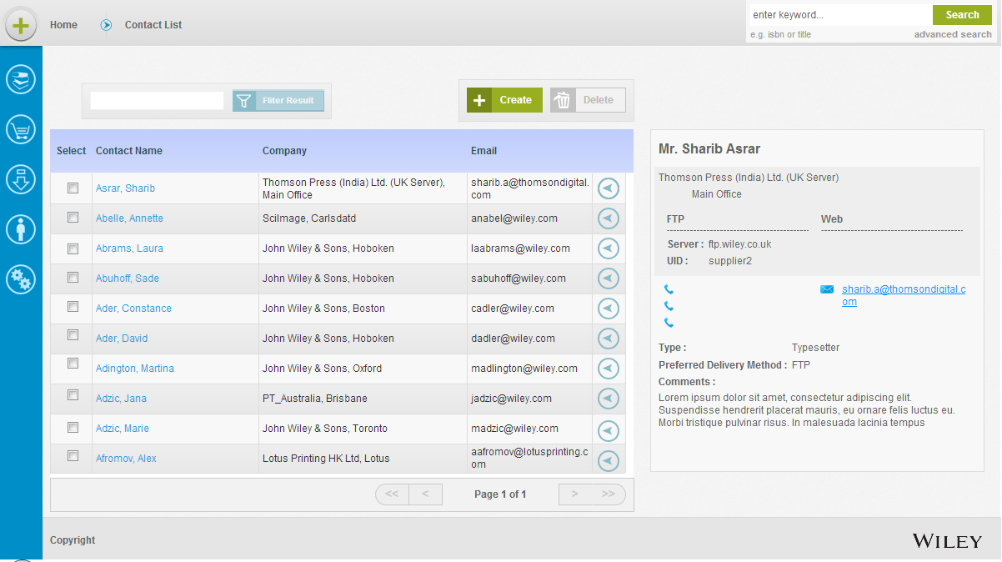

### Screen Elements

The following is a list of all elements contained on the ***Contacts List:***

***Select***

|  |  |
| --- | --- |
| **Type:** | Check box |
| **Label:** | Select |
| **Behavior:**  **Default** | By checking this box, user is able to designate one or more contact records that may be edited or deleted when the appropriate button is selected.  unchecked |

***Contact Name***

|  |  |
| --- | --- |
| **Type:** | Column text holder |
| **Label:** | Contact Name |
| **Behavior** | Contains the full name *(last\_name, first\_name)* as well as the role that applies to the name shown in parenthesis. |

***Company***

|  |  |
| --- | --- |
| **Type:** | Column text holder |
| **Label:** | Company |
| **Behavior** | Contains the full name *(last\_name, first\_name)* as well as the role that applies to the name shown in parenthesis. |

***Email***

|  |  |
| --- | --- |
| **Type:** | Column text holder |
| **Label:** | Email |
| **Behavior** | Contains the email address in a generally recognized format of *jsmith@example.org*. It consists of two parts: username of recipient and a domain name. |

**For General User/ Production User**

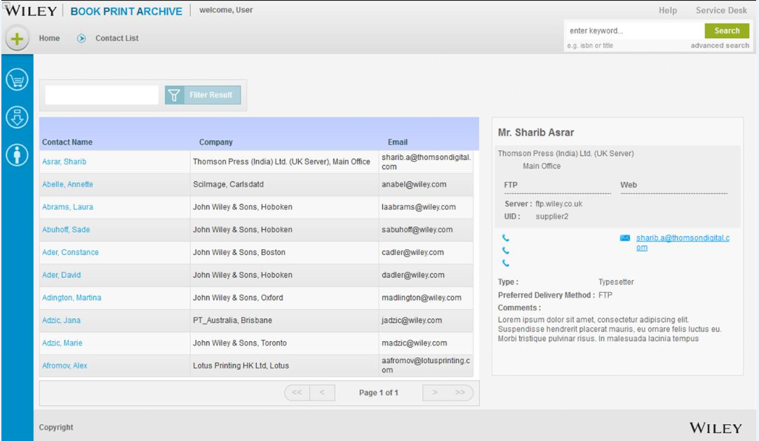

### Screen Elements

The following is a list of all elements contained on the ***Contacts List:***

***Contact Name***

|  |  |
| --- | --- |
| **Type:** | Column text holder |
| **Label:** | Contact Name |
| **Behavior** | Contains the full name *(last\_name, first\_name)* as well as the role that applies to the name shown in parenthesis. |

***Company***

|  |  |
| --- | --- |
| **Type:** | Column text holder |
| **Label:** | Company |
| **Behavior** | Contains the full name *(last\_name, first\_name)* as well as the role that applies to the name shown in parenthesis.. |

***Email***

|  |  |
| --- | --- |
| **Type:** | Column text holder |
| **Label:** | Email |
| **Behavior** | Contains the email address in a generally recognized format of *jsmith@example.org*. It consists of two parts: username of recipient and a domain name. |

**Filter Contacts**

|  |  |
| --- | --- |
| **Type:** | Text box |
| **Label:** | <Last name, First name> |
| **Behavior:**  **Default** | When a text is entered, the Contact list is filtered to further narrow down the based on first five characters of <last name, first name> format. Maximum number of character system can filter by is five.  Blank |

If filter criteria does not match any contact, error message is displayed “No Record Found”.

### 3.1.3 Update Contact

### Description

Admin Users are able to ***Update Contact Detail*** by selecting the particular contact record from the ***Contact List.*** .

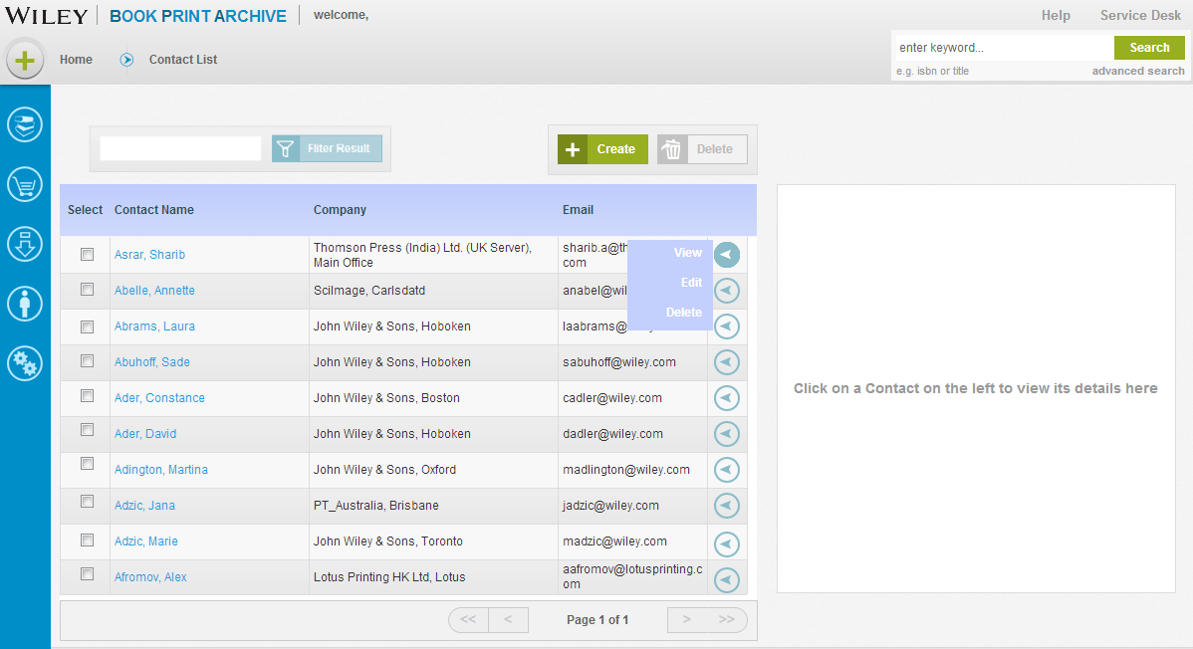

### Navigation

When the ***Select*** checkbox alongside the Contact record is checked, this ***Contact Detail*** panel is rendered on the right hand side of the ***Contact List*** page. When the admin user chooses to update contact details, the admin user clicks <***Edit>*** button from collapsible buttons situated on the right side of Contact record. When the ***<Edit>*** button is selected, Contact Details dialog box is rendered with existing Contact information displayed. All fields on the page are available for updating. When the admin user selects ***Edit***, the updates are saved to the Contact record. The Admin User has the option to exit before saving any edits made to the Contact record by clicking the ***<Cancel>*** button. On successfully update, a message is displayed “Contacted successfully saved”. However, System displays the contact list with most recent page, filter and sort settings.

### 3.1.4 Delete Contact

### Description

Admin Users are able to ***Delete Contact***  by selecting the particular contact record from the ***Contact List.*** A contact may not be deleted if he/she is currently associated with any WIP titles(Moved to iteration 2)

### Navigation

When the ***Select*** checkbox alongside the Contact record is checked, this ***Contact Detail*** panel is rendered on the right hand side of the ***Contact List*** page. Users can also delete a contact from the action button against each contact.

When the user chooses to delete contact, the user clicks <***Delete>*** button. A dialog box will prompt user to confirm with the message “You are about to delete item(s). This action cannot be undone in the future. Do you wish to continue?”

Once confirmed, the contact is removed from the Contact List. However, System displays the contact list with most recent page, filter and sort settings.

## 3.2 Manage Companies

### Description

All users are able view all listed companies irrespective of their user roles. In addition to viewing companies list, the Administrator role is able to create, update, view or delete companies when needed.

### 3.2.1 Create Company

### Description

Administrative users are able to create a new Company by selecting ***Create New Company*** option from ***Quick Launch*** menu.

### Navigation

When the user clicks on the ***Create New Company***  link on the menu, the ***Create New Company*** dialog box is rendered. After the user enters all the required Company information, the user then clicks the ***<Create>*** button. A check is put in place to verify that a company name does not already exist. If the company already exists, an error message is displayed “Company already exists”. If the company is successfully created, a message is displayed “Company successfully created” and the new Company is saved and now displayed in the Company List alphabetically based on company name in a paginated format. However, System displays the company list with most recent page, filter and sort settings. If user does not enter all mandatory fields during creation, an error message is displayed highlighting the missing fields. Sample error message for Company and Location creation-

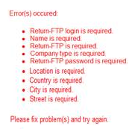

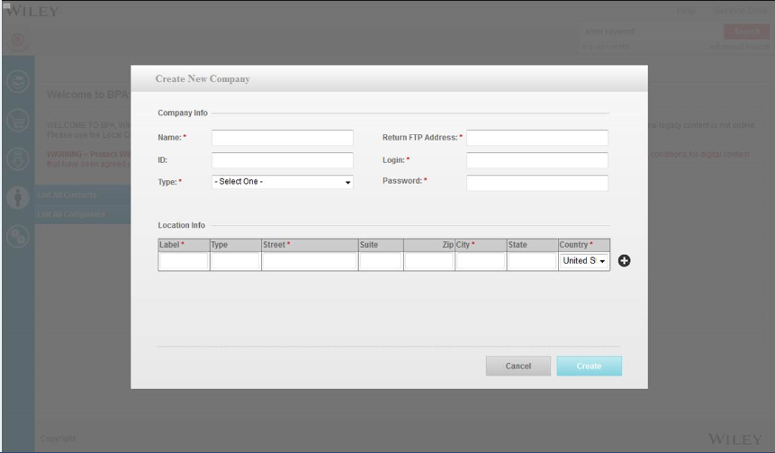

If the user clicks the ***<Cancel>*** button, information is not saved and the ***Create New Company*** dialog box is closed, returning the focus to the application Home page.

### Screen Elements

The following is a list of all elements contained in a ***Company***  record:***:***

***Name***

|  |  |
| --- | --- |
| **Type:** | drop-down selection box |
| **Label:** | Company |
| **Values:**  **Behavior** | Accommodates up to a maximum of fifty alpha-numeric characters  **Mandatory** – Contact must be associated with a Company that resides in **Company List** |

***ID***

|  |  |
| --- | --- |
| **Type:** | text box |
| **Label:** | ID |
| **Length:**  **Behavior** | Accommodates up to a maximum of fifty alpha-numeric characters  When admin user selects a Company that is associated with the Contact, the Login field on the Contact form will automatically capture Login information associated with the Company FTP address. |

***Type (Preferences)***

|  |  |
| --- | --- |
| **Type:** | Drop-down selection box |
| **Label:** | Type |
| **Values:** | Printer, Typesetter, Graphic Designer, EBook Distributor, Conversion Vendor, Wiley Staff, Other |

***Return FTP : Address***

|  |  |
| --- | --- |
| **Type:** | text box |
| **Label:** | Address |
| **Length:**  **Behavior** | Accommodates up to a maximum of fifty alpha-numeric characters  When admin user selects a Company that is associated with the Contact, the Address field on the Contact form will automatically capture FTP address associated with that Company. |

***Login***

|  |  |
| --- | --- |
| **Type:** | text box |
| **Label:** | Login |
| **Length:**  **Behavior** | Accommodates up to a maximum of fifty alpha-numeric characters  When admin user selects a Company that is associated with the Contact, the Login field on the Contact form will automatically capture Login information associated with the Company FTP address. This is a mandatory field |

***Password***

|  |  |
| --- | --- |
| **Type:** | text box |
| **Label:** | Password |
| **Length:**  **Behavior** | Accommodates up to a maximum of fifty alpha-numeric characters  When admin user selects a Company that is associated with the Contact, the Password field on the Contact form will automatically capture Password information associated with the Company FTP address. This is a mandatory field |

***Add Location***

|  |  |
| --- | --- |
| **Type:** | Button |
| **Label:** | Location |
| **Values:**  **Behavior** | ***Add a new row in the location table***  **Company** must be associated with Location that resides in the **Locations List**. |

#### 3.2.1.1. Add Location

### Description

Administrative users are able to add location for the Company by selecting ***Add Location button*** option from ***Create Company*** page. A check is put in place to verify that a location name does not already exist. If the location already exists, an error message is displayed “Location already exists”.

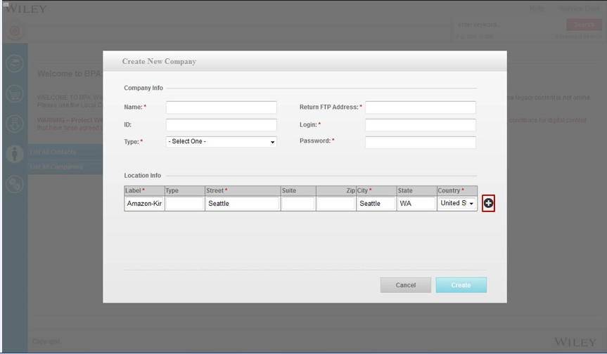

### Navigation

When the admin user clicks on  button a new row is added to the location info table. The new location for the Company is saved and now displays in the Company List.

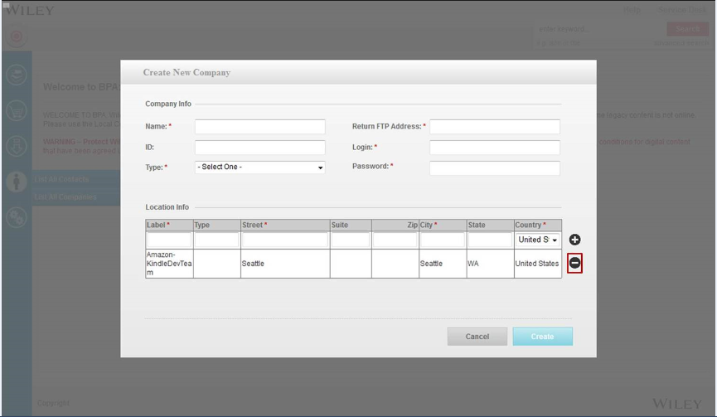

When the admin user clicks on the  button the row containing location information is deleted.

### Screen Elements

The following is a list of all elements contained in a ***Location info*** record:***:***

***Label***

|  |  |
| --- | --- |
| **Type:** | Text box |
| **Label:** | Address |
| **Length:**  **Behavior** | Accommodates up to a maximum of ten alpha-numeric characters  ***Mandatory***: When admin user selects a label to identify this Company address e:g Headquarter, Warehouse etc or any user preference. It only is used to distinguish this address for user. |

***Type***

|  |  |
| --- | --- |
| **Type:** | Text box |
| **Label:** | Address |
| **Length:**  **Behavior** | Accommodates up to a maximum of fifty alpha-numeric characters  When admin user selects a Company that is associated with the Contact, the Address field on the Contact form will automatically capture FTP address associated with that Company. |

***Street***

|  |  |
| --- | --- |
| **Type:** | text box |
| **Label:** | Address |
| **Length:**  **Behavior** | Accommodates up to a maximum of fifty alpha-numeric characters  **Mandatory**: Street address of the company. |

***Suite***

|  |  |
| --- | --- |
| **Type:** | Text box |
| **Label:** | Address |
| **Length:**  **Behavior** | Accommodates up to a maximum of ten alpha-numeric characters  Suite or apartment address associated with that Company. |

***Zip***

|  |  |
| --- | --- |
| **Type:** | Text box |
| **Label:** | Address |
| **Length:**  **Behavior** | Accommodates up to a maximum of ten alpha-numeric characters  Zip code information of the address the company is located in |

***City***

|  |  |
| --- | --- |
| **Type:** | Text Box |
| **Label:** | Address |
| **Length:**  **Behavior** | Accommodates up to a maximum of ten alpha-numeric characters  **Mandatory**: City information of the company |

***State***

|  |  |
| --- | --- |
| **Type:** | Text box |
| **Label:** | Address |
| **Length:**  **Behavior** | Accommodates up to a maximum of ten alpha-numeric characters  **State**  information of the company |

***Country***

|  |  |
| --- | --- |
| **Type:** | Drop down |
| **Label:** | Address |
| **Length:**  **Behavior** | Accommodates up to a maximum of ten alpha-numeric characters  **Mandatory**: Country information of the company |

### 3.2.2 View Company

### Description

Users are able to ***View Company Detail*** by selecting the particular company record from the ***Company List.*** Admin user will only have the edit, create and delete functions.

### Navigation

Users can view Company details by selecting item from company list or from the action button against each company

**For Admin User:**

When the ***Select*** checkbox alongside the Company record is checked, this ***Company Detail*** preview panel is rendered on the right hand side of the ***Company List*** page.

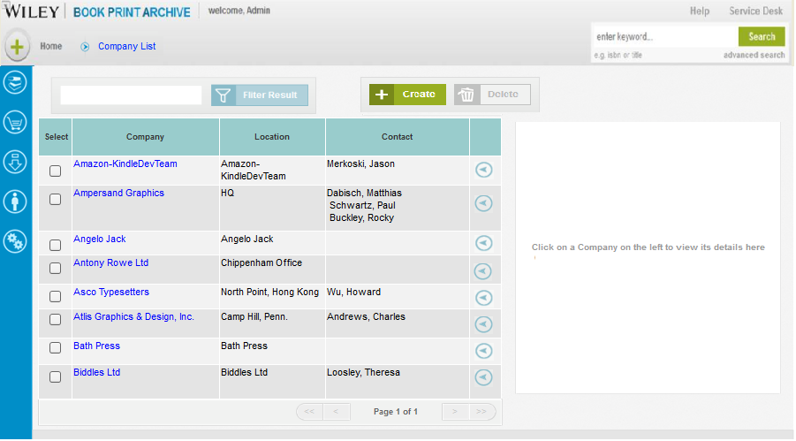

### Screen Elements

The following is a list of all elements contained on the ***Company List:***

***Select***

|  |  |
| --- | --- |
| **Type:** | Check box |
| **Label:** | Select |
| **Behavior:**  **Default** | By checking this box, user is able to designate one or more company records that may be edited or deleted when the appropriate button is selected.  Unchecked |

***Company***

|  |  |
| --- | --- |
| **Type:** | Column text holder |
| **Label:** | Company |
| **Length:**  **Behavior** | Accommodates up to a maximum of fifty alpha-numeric characters  Contains the full name of the company |

***Location***

|  |  |
| --- | --- |
| **Type:** | Column text holder |
| **Label:** | Location |
| **Behavior** | Contains the location detail such as location label |

***Company Name***

|  |  |
| --- | --- |
| **Type:** | Column text holder |
| **Label:** | Contact Name |
| **Behavior** | Contains the full name *(last\_name, first\_name)* as well as the role that applies to the name shown in parenthesis.. |

**For General User/ Production User**



(*NOTE: this is the contact view- and company view for general and production user will be similar and read-only- details of the view below*)

### Screen Elements

The following is a list of all elements contained on the ***Company List:***

***Company***

|  |  |
| --- | --- |
| **Type:** | Column text holder |
| **Label:** | Company |
| **Length:**  **Behavior** | Accommodates up to a maximum of fifty alpha-numeric characters  Contains the full name of the company |

***Location***

|  |  |
| --- | --- |
| **Type:** | Column text holder |
| **Label:** | Location |
| **Behavior** | Contains the location detail such as location label |

***Company Name***

|  |  |
| --- | --- |
| **Type:** | Column text holder |
| **Label:** | Contact Name |
| **Behavior** | Contains the full name *(last\_name, first\_name)* as well as the role that applies to the name shown in parenthesis.. |

**Filter Company**

|  |  |
| --- | --- |
| **Type:** | Text box |
| **Label:** | <Company name> |
| **Behavior:**  **Default** | When a text is entered, the Company list is filtered to further narrow down the based on first five characters of company name. Maximum number of character system can filter by is five.  Blank |

If filter criteria does not match any company, error message is displayed “No Record Found”.

### 3.2.3 Update Company

### Description

Admin Users are able to ***Update Company Detail*** by selecting the particular company record from the ***Company List.***

### Navigation

When the ***Select*** checkbox alongside the Company record is checked, this ***Company Detail*** panel is rendered on the right hand side of the ***Company List*** page. When the admin user chooses to update company details, the admin user clicks <***Edit>*** button from collapsible buttons situated on the right side of Company record. When the ***<Edit>*** button is selected, Company Details dialog box is rendered with existing Company information displayed. All fields on the page are available for updating. When the admin user selects ***Edit***, the updates are saved to the Company record. The Admin User has the option to exit before saving any edits made to the Company record by clicking the ***<Cancel>*** button. On successful update, a message is displayed “Company successfully saved”. However, System displays the company list with most recent page, filter and sort settings.

### 3.2.4 Delete Company

### Description

Admin Users are able to ***Delete*** Company by selecting the particular Company record from the Company ***List.*** A Company may not be deleted if he/she is currently associated with any WIP titles (Iteration 2)

### Navigation

When the ***Select*** checkbox alongside the Company record is checked, this Company ***Detail*** panel is rendered on the right hand side of the Company ***List*** page. Users can also delete a company from the action button against each company. When the user chooses to delete Company, the user clicks <***Delete>*** button.

A dialog box will prompt user to confirm with the message “You are about to delete item(s). This action cannot be undone in the future. Do you wish to continue?”

Once confirmed, the company is removed from the Company List. However, System displays the company list with most recent page, filter and sort” settings.